Robot youpi
kinematic diagram and DH parameters
Last revision : 19/10/24 – DANIEL Olivier
θ4
θ5
θ3
θ2
θ1
x0
z0
y0
z3 | y4

x3 | z4
y3 | x4

z2
x2
y2
z1
x1
y1
X5

Z5

Y5
Robot youpi's DH Parameters
Joint i | θi (deg) | αi (deg) | ai / ri (cm) | di (cm)
1 | 180 | 90 | 0 | 28
2 | 90 | 0 | 16.2 | 0
3 | 0 | 0 | 16.2 | 0
4 | 90 | 90 | 0 | 0
5 | 0 | 0 | 0 | 15
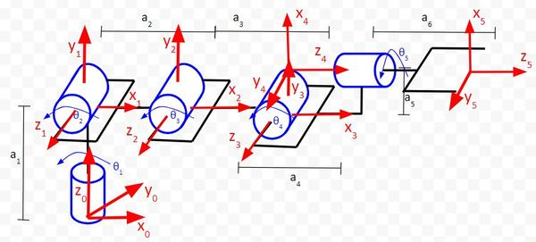
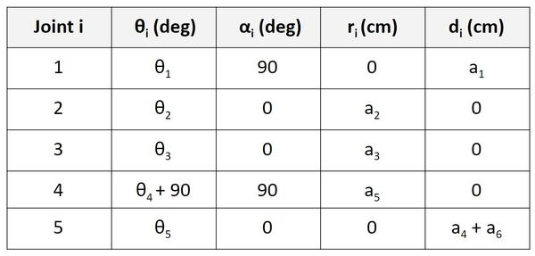
a1 : 280mm
a2 : 162mm
a3 : 162mm
a4 : 0mm
a5 : 150mm
Online example :
1)The z-axis is the axis of rotation for a revolute joint.
2)The x-axis must be perpendicular to both the current z-axis and the previous z-axis.
3)The y-axis is determined from the x-axis and z-axis by using the right-hand coordinate system
(You stick your fingers in the direction of x. Your thumb goes in the direction of z. Your palm faces the direction of y).
4)The x-axis must intersect the previous z-axis (rule does not apply to frame 0).
* θ is the angle from x_{n-1} to x_{n} around z_{n-1} (trigonometric sense.)
* α is the angle from z_{n-1} to z_{n} around x_{n} (trigonometric sense.)
* r (sometimes you’ll see the letter ‘a’ instead of ‘r’) is the distance between the origin of the n-1 frame and the origin of the n frame along the x_{n} direction.
* d is the distance from x_{n-1} to x_{n} along the z_{n-1} direction.

How to :

